***SOFTWARE REQUIREMENTS SPECIFICATION DOCUMENT***

**Document ID:** 1234

**Author**: SURESHKRISHNA G

**Version**: 1

**Date**: March 13, 2024

**INDEX**

1. **Objective and scope…………………………………………………3**
2. **Project End Users…………………………………………………...4**
3. **Features……………………………………………………………...4**
   1. Login to the app………………………………………………....4
   2. High Video and audio quality……………………………………5
   3. Multi participant video calls……………………………………..5
   4. Real time chat for side conversations……………………………6
   5. Intutive interface for Everyone…………………………………..6
   6. Use case diagram………………………………………………...7
   7. Reports…………………………………………………………...7

**1.Objective and Scope**

Themain objective of the video conferencing app is to connect many of the individuals virtually enabling the audio, chat and video features. This particular app also provides any type of companies to conduct the meeting with an ease and this app is also an user friendly one.

By digitally simulating an in-person conference environment, video conferencing software aims to enable real-time communication between individuals who are located in separate places.

The scope of the project includes the following basic features:

* To Facilitate real-time face-to-face interaction between geographically dispersed individuals or teams. Enable screen sharing for presentations, brainstorming, and co-working on documents. Integrate features like chat and virtual whiteboards for interactive communication.
* Allow scheduling, sending invites, and managing participant access for organized meetings. Offer recording options for future reference or sharing presentations. Provide in-meeting controls like muting, attendee management, and screen share control for hosts.
* Implement encryption protocols to ensure secure communication and data transmission. Allow for password-protected meetings and user authentication for access control. Provide features like waiting rooms and host controls to maintain a secure meeting environment.
* Explore virtual backgrounds, breakout rooms for smaller group discussions, and AI-powered noise cancellation. Implement features like real-time captions, sentiment analysis, and meeting summaries for enhanced communication.Integrate interactive tools like polls, quizzes, and whiteboards for more engaging presentations.

2. Project End Users

Those who cant able to meet physically or in an urge of meeting or those who are attending online classes or meeting with the clients who are in abroad.

3.Features

3.1 Login to the app

Each and every user can enter in to the meet using the login id link with the meeting name and password so that unwanted people can be avoided easily.

User Name: In the user name only Alphabets, Numbers, Dot (.) symbol and underscore (_) symbol.

Password : It can be anything of the host choice.

3.2High Video and audio quality

* High-definition video conferencing, this allows for clear and lifelike communication, fostering better engagement among participants.
* Voice over IP (VoIP),Enables high-quality audio for clear communication without relying on traditional phone lines.
  1. Multi participant video calls
* Gone are the days of physical limitations on meeting spaces. Video conferencing apps can accommodate groups of all sizes, from small team huddles to large company-wide meetings.
* This flexibility allows for inclusive communication and participation, regardless of location.



3.4 Real time chat for side conversations

* Live chat functionality provides a text window alongside the video feed. This enables participants to ask quick questions, share links, or provide commentary without interrupting the speaker.
* It's like having a virtual sidebar conversation that keeps the meeting focused while facilitating additional communication.
  1. Intutive interface for Everyone
* A user-friendly interface is crucial for widespread adoption. A well-designed app should be easy to navigate, regardless of technical expertise.
* This ensures everyone can join and participate in meetings with minimal setup time, maximizing efficiency and minimizing frustration.
  1. Use case diagram:

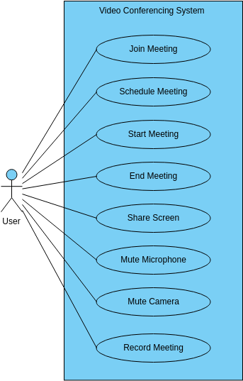

* 1. Reports

The video conferencing app project aims to revolutionize remote communication. It leverages cutting-edge technology to provide seamless video and audio connectivity. Features include screen sharing, virtual backgrounds, and real-time messaging. The user-friendly interface ensures effortless navigation for users of all levels. With robust security measures in place, it guarantees privacy and confidentiality.